Theoretical justification for obtaining incorrect results when measuring liquid permeability

*Matvey Yankovsky*

1. Basic information about permeametry

Liquid permeametry is one of the most important part in heat pipes and heat transfer technology developing [1]. In heat pipes, liquid transports using porous materials. The flow rate of a fluid in a porous body depends on the porosity and permeability of the body. The permeability of a porous body can generally be calculated using Darcy's formula (law):

$$Q=\frac{k∆p}{μ∆x}$$

where $Q$ is a flow of liquid in porous material; $\frac{∆p}{∆x}$ is a gradient of pressure, which is the pressure drop p per unit length of the path of the liquid or gas and is directed in the direction of the pressure drop; $μ$ is a dynamic viscosity of liquid; $k$ is the permeability coefficient that characterizes a particular porous material.

Basic scheme of an experiment for measuring the permeability of a material using a liquid is to pass a certain amount of liquid through a completely wetted sample of this material and measure the speed of its passage through the thickness of the sample [2]. Speed depends on the pressure of the liquid when it comes into contact with the sample. In real life we can find a lot of permeability measurement technologies such as steady-state methods, multiple-core method, high rate method [3] and others. One of the simplest and the most accurate method is ambient pressure test. Water column is located above the sample, the sample is located in a sealed cell through which the liquid flows from the column. The liquid is drained through a hole located at the bottom of the cell. Sample and the cell must be filled only with liquid. The presence of air in the cell or in the sample leads to the fact that the experimental results of permeability are lower than expected. At the top of the column there is a hole for air to enter the column when draining liquid from it. The experiment is carried out at atmospheric pressure, the pressure of the column height of the column is easy to calculate using Pascal's law. This method allows us to calculate the permeability of highly permeable materials, since the low pressure of the column does not allow the liquid to flow quickly through the sample. The height of the column is measured using a float level gauge. The pressure decreases evenly. Another option for a simple test is to create a pressure above the column pressure (the height of the column of liquid in the column). This is quite easy to do by connecting the compressor / pump to the hole at the top of the column. The air will create additional pressure and allow the liquid to pass through the sample faster. The accuracy of the measurement remains the same as in tests conducted using atmospheric pressure since in such an experiment the measurement result is affected only by the liquid level in the column.

1. Permeability measurements using Liquid Permeameter LP200-A

Two types of tests described above are performed on this device. Tests with excess pressure are performed correctly (due to the lack of approximation to the threshold values measured by the device, as well as the elimination of possible air bubbles in the cell, they simply float away under pressure). However, it is not always possible to carry out tests at overpressure, since, for example, for highly permeable samples, the measurement error will be large. And when conducting tests at atmospheric pressure, there are many nuances that often cannot be eliminated. 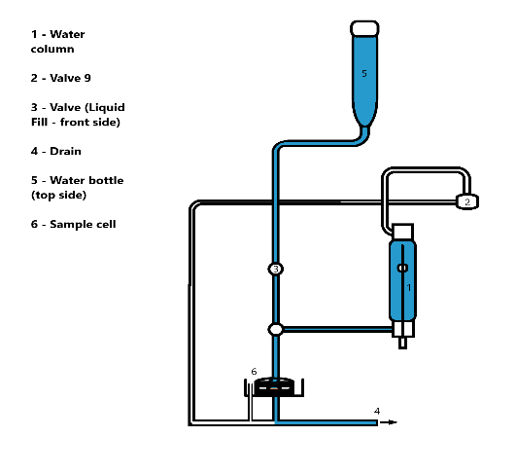

Figure 1. Scheme of ambient pressure test

In both cases, the sample must be completely filled with liquid, which is quite difficult to do (you can use boiling or vacuuming followed by filling the sample with water, but you can’t be 100% sure that there will be no air left in the sample). The sample must be of the same thickness over the entire area and not deform under water pressure (this does not happen in atmospheric pressure tests)

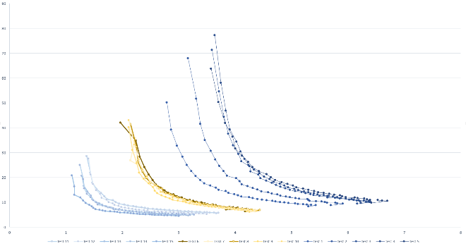

Figure 2. Problem of decreasing results of measurement of the sample permeability coefficient. Graph shows 15 tests, blue – first tests, yellow – middle tests, light blue – last tests. On the Y axis there is pressure, on the X axis there is flow through the sample

When testing various samples on the LP200, it can be noticed that from test to test, the permeability value of the sample can either change significantly or be stationary within the measurement error. In order to understand the reason for such different results, it is necessary to understand the design of this device (I conducted all tests at atmospheric pressure, so I will consider the scheme of the ambient pressure test). The scheme is shown on Fig.1. The water bottle (5) is filled manually, then when the tap (3 - liquid fill) is opened, the water fills the column (1) and the sample cell. When the column is filled to about 30 cm, the tap is closed, the test is started and water is drained from the column through the sample to the drain system (4). The result of the test is a table, which shows the values of water flow in various units (A - cc/sec, B - liters/min/cm^2, C - liters/psi/cm^2/sec, D - liters/psi/cm^2/min) through the sample at a certain pressure (the pressure is calculated from the height of the liquid column in the column), permeability calculated in Darcy and its average value, graphs of the flow dependence on pressure.

The results of the permeability value are calculated automatically using the pre-set values (before the test) of the sample thickness, fluid viscosity, diameter and calculated pressure points and the corresponding flow using the formula:

$$C=\frac{8FTV}{πD^{2}(P^{2}-1)}$$

Where C – permeability coefficient, F – flow in cc/sec, T – thickness in mm, V – fluid viscosity in CP, D – diameter in mm, P – pressure in atm. The formula is derived from Darcy's law using the standard value of pressure and temperature.

The average value of the permeability coefficient is considered as follows. First, you need to calculate the weight of the pressure change at a certain point in relation to the entire period of pressure change as a percentage. Next, you need to compare the value of the permeability coefficient at this point to the value of the weight of the pressure change at this point. The arithmetic mean of the Darcy values at the pressure points for which the pressure change was calculated must be divided by this weight coefficient and add all the resulting weight values of the permeability coefficient. Errors are calculated by summarizing measurements error, device error and random error.

During tests at atmospheric pressure on this device, the results were chaotic, for example there is an example of two same-conditions tests. On the Y axis there is permeability coefficient in Darcy and on the X axis there is pressure in Bar: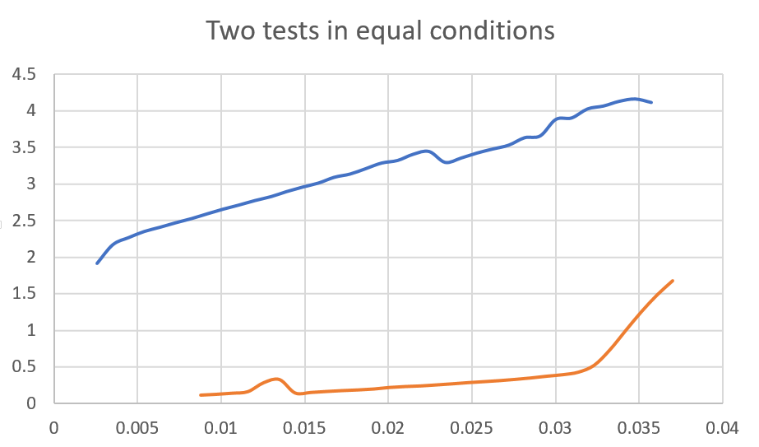

Figure 3. Two same-conditions tests on LP200

As a rule, the value of the sample permeability coefficient drops from test to test, until at some point the flow of liquid through the sample does not stop at all. However, this occurs only if the sample is not removed from the cell before the test. That is, before the first test, put it and do tests only by filling and merging the column. However, if the sample is removed from the cell before each test, and the cell is filled with water when it is returned to its place, the problem persists. In this case, the reason for the decrease in permeability may be the air that enters the system after the liquid is completely drained from the column by the end of the test and air that enters system and cell during preparation for the test. During the discharge of the liquid from the column, there is air in the cell with the sample, which in no way can escape from there. Air prevents laminarization and normalization of the fluid flow through the sample (bubbles located in the cell and in the tubes of the system try to get out to the top, and water flows down and at some point the fluid flow is blocked by the bubble). Air bubbles were repeatedly observed by me and my colleagues during tests in various tubes of the device. A possible solution is to fill the system with water before the test so that all the bubbles come out. This can be done by inverse filling. If you put the sample in a cell and connect a pressure water pressure to the water drain hose, the air under this pressure will exit through the column (at the top of the column is a hole for its exit). At the same time, you must fill the column in the standard way. Then the water pressure system is switched off and a laminar uniform flow of water through the sample from the drain system is observed. In this case, the measurement results are constant from test to test (figure 4), but the inverse filling system itself is not only difficult to perform (I used a water bottle to fill the system from the bottom up and required disconnecting before starting the test), but also requires disconnecting some pipes and systems for conducting pressure tests.

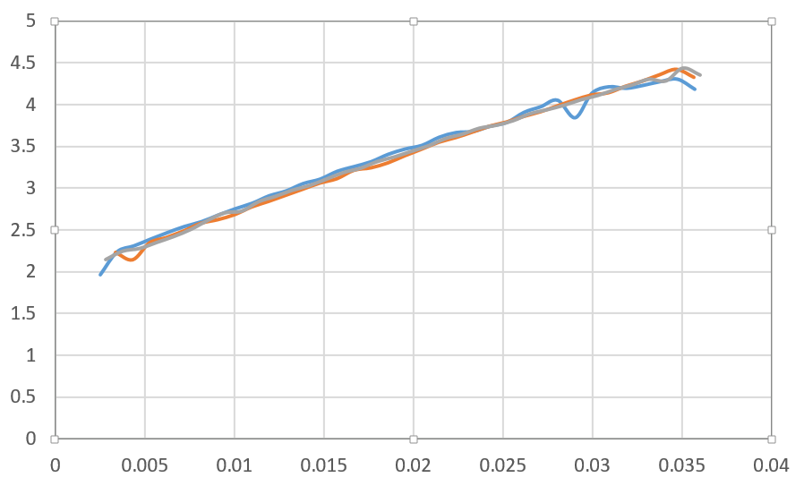

Figure 4. Inverse filling tests with drain pipe

In addition, the length of the drain pipe (its length is about a meter) with its uniform filling gives an additional flow, which appears due to the fact that the water that is in the tube "pulls" the water that is above the point of discharge from the drain pipe. Incorrect permeability calculations are obtained, since the system for calculating the permeability coefficient uses the height of the liquid column only in the column to calculate the pressure without taking into account the height of the liquid column after the water exits the column. Consequently, the flow through the sample is greater than if the water left the system immediately after passing the sample, and the pressure is the same, hence the calculated permeability is greater than it could be without drain pipe. Figure 5 shows that flow (it is on the Y axis, pressure is on the X xis) is much smaller than with drain tube. At the point where the pressure is 0.02 bar, the flow is approximately 1 cc/sec when the drain pipe is not connected, and approximately 3.5 cc/sec when the drain pipe is connected.

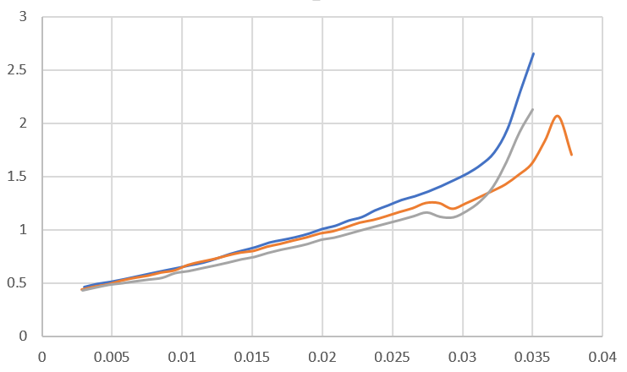

Figure 5. Only water in the system. Tests without drain pipe

To fill the system with a disconnected drain pipe, it is necessary to simply close the drain hole (it is located under the sample cell), fill the cell with water and drain the water from the penetrometer until the moment when water without bubbles begins to flow evenly from there (the penetrometer is a tube that goes from the column to the sample cell, it is disconnected in order to put the sample in the cell). Next, attach the penetrometer to the cell, so the system will have water without air.

However, even if the cell is filled with water when performing tests without a drain pipe, the results are not always stable. 10 consecutive tests may show results with a slight deviation from the average permeability value, and the 11th test will show a value that is twice less than the average for previous tests.

It is *very important* to clarify that when conducting an experiment of measuring permeability using gas rather than liquid, the permeability coefficient in the case of gas is higher than in the case of liquid, and since a highly permeable (~10 Darcy) sample of porous copper was used for the tests, the differences in permeability for liquid and gas should not be noticeable (the difference lies within the measurement error) [4].

1. Summary and evaluation

Tests performed on the LP200 device showed that the measurement of sample permeability at atmospheric pressure is performed incorrectly, the results are mostly chaotic or the measurement error is very large even if there is a sufficient sample of measurement results (5-10). Stable results are obtained only when the system is filled with liquid using a drain tube. In this case, the permeability coefficient measured with the LP200 differs slightly from the coefficient measured with gas on the Cappilary Flow Porometer, but due to the fact that the inverse filling of the system with water is extremely difficult and rough in its execution (it is necessary to disable and open the pressure permeability measurement systems, change the internal device), and this method does not comply with safety regulations, the permeability measurement of even highly permeable samples must be performed under pressure on LP200, alternating tests on the Cappilary Flow Porometer and Liquid Permeameter until a sample with a sufficient confidence coefficient is obtained.

Tests are better performed using the gas permeability of the sample, they are easier to perform and much more accurate when calculating the permeability of the device. In the case of porous copper samples that are used in heat pipes, the rate of liquid filtration through a porous structure is simply compared with the rate of gas filtration through the same structure, it is necessary to know the dynamic viscosity, density and coefficient Re (number of Reynolds) for liquid and gas. We know that in heat pipes, the filtration rate of a liquid (in most cases water, so all calculations are performed using water characteristics) through a porous structure is approximately 0.5 to 5 cm/sec, so it is necessary to understand which gas flow through the sample corresponds to this filtration rate. To calculate this dependence we need to know filtration velocity of Gas through the sample (1), Reynolds coefficient (2):

1: $V=\frac{Q}{S}$, where S – surface area of the sample

2: $Re= \frac{ρV}{μ}$, where $ρ$– density of gas, V – filtration velocity through the sample, $μ$– dynamic viscosity of gas.

The Reynolds coefficient is the same for filtering liquid and gas through the same structure, so it is easy to calculate the water filtration rate and find its correspondence with the gas flow (Figure 6).

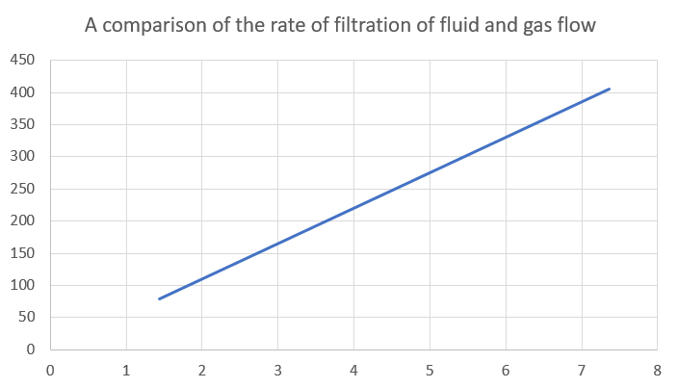

Figure 6. On the X axis there is water filtration velocity in cm/sec, on the Y axis there is Gas flow in cc/sec

# REFERENCES

[1] Yuxue Liu “Principle, Application and Development of Heat Pipe Technology” School of Geoscience and Technology, Southwest Petroleum University.

[2] State standard of RF 25283-93. The sintered permeable materials. Determination of the permeability of liquids. 1997-01-01.

[3] Richard L Christiansen, Susan M. Howarth “Literature Review and Recommendation of Methods for Measuring Relative Permeability of Anhydrite from the Salado Formation at the Waste Isolation Pilot Plant” SAND93-7074 1995.

[4] L. J. Klickenberg “PERMEABILITY OF POROUS MEDIA FOR LIQUIDS AND GASES”, 2012